Organization of Computer
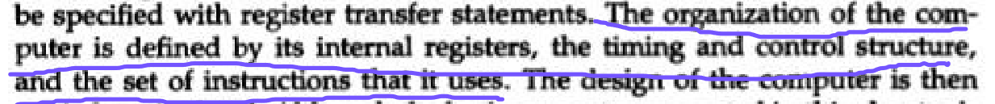
Digital Modules
Microoperation
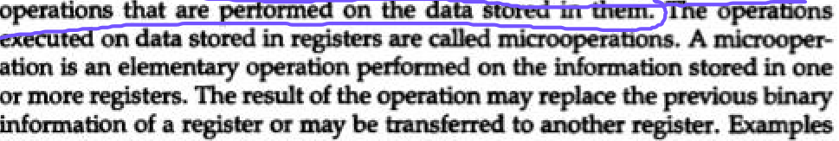
Digital System
Internal Hardware Organization
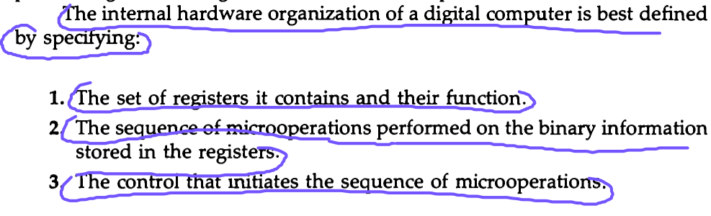
Program
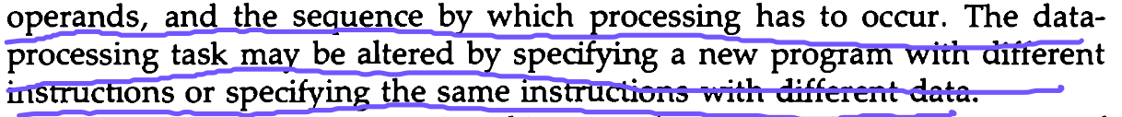

Instruction Code
Operation Code
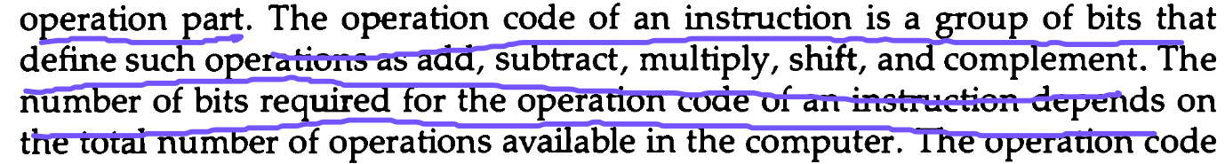
Stored Program Organization
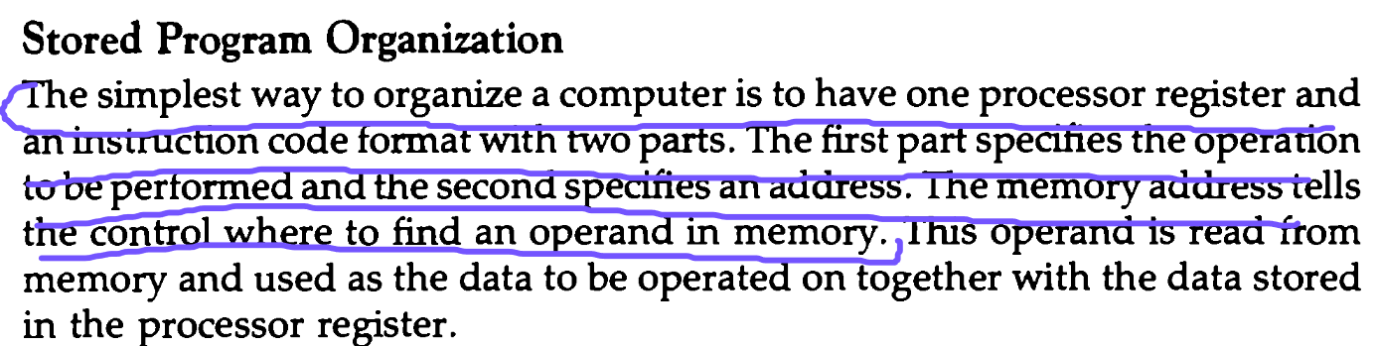
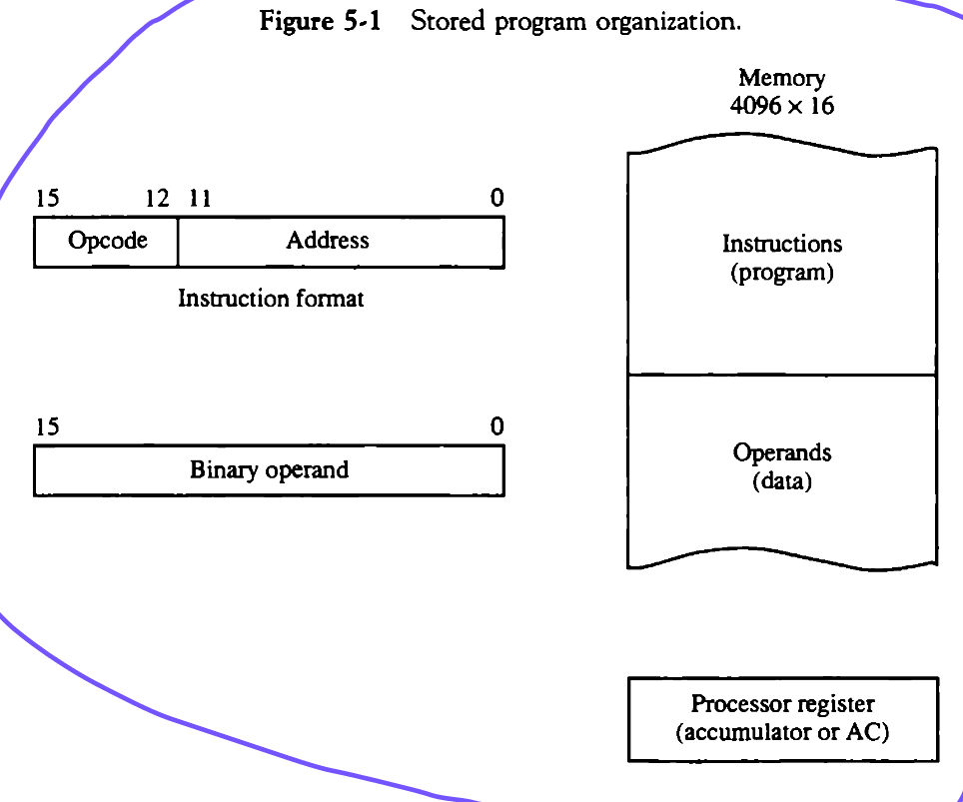

Accumulator
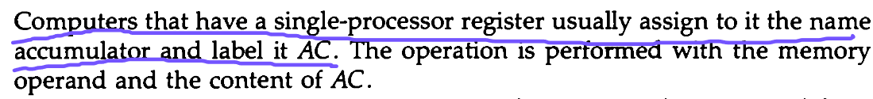
Indirect addressing,

the instruction contains a memory address that, in turn, holds the actual address of the data.The CPU follows this indirect address to locate the data. The indirect address serves as a pointer to the actual memory location.An example might be "load the value from the memory address stored in memory location 2000 into register B.

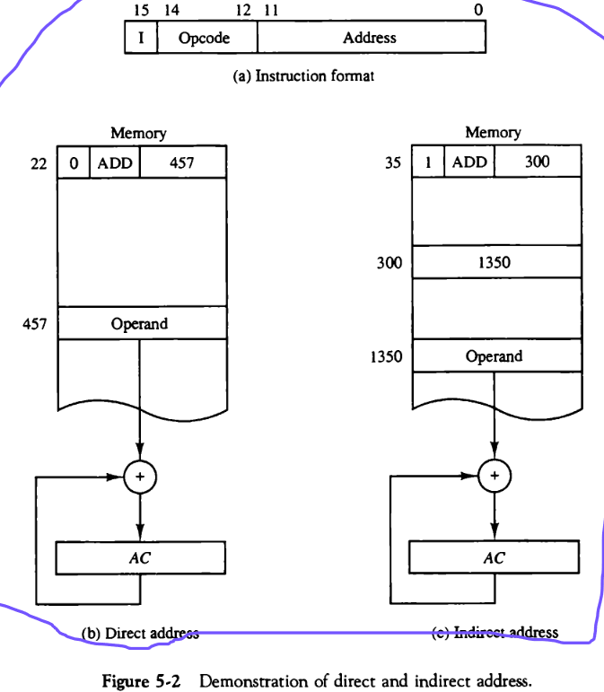
Computer Register
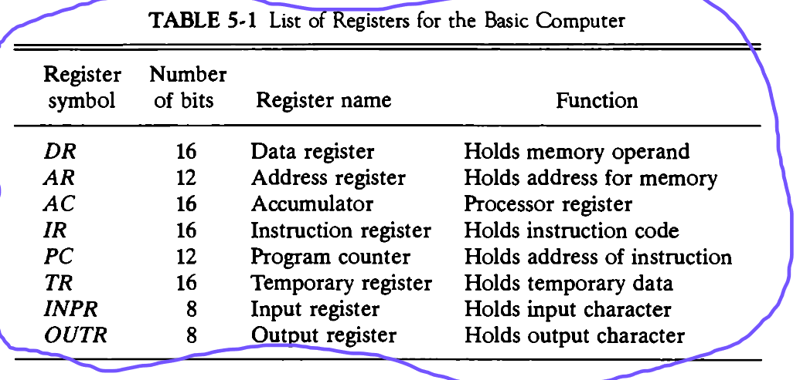
Common Bus System
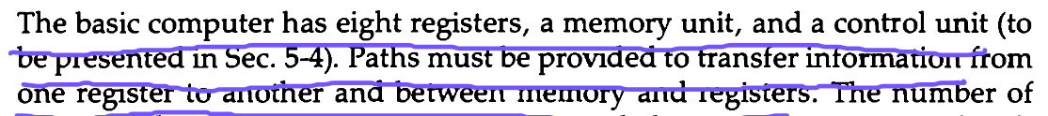
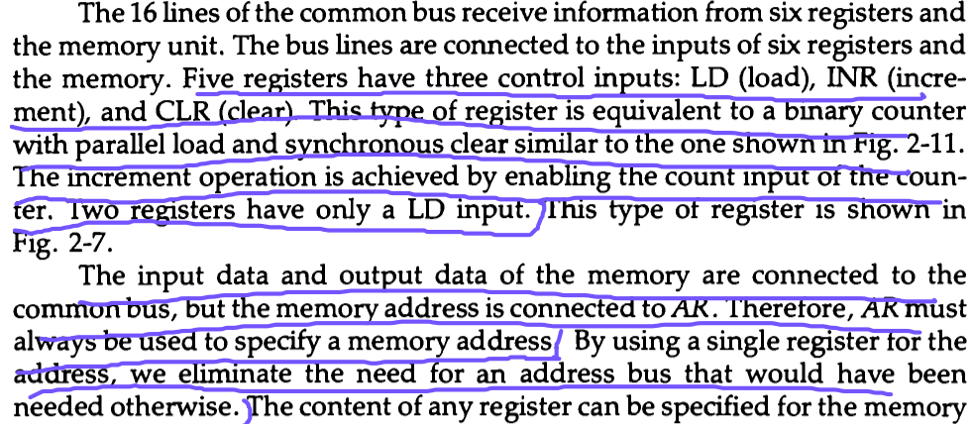
LD (Load) is used to receive data.

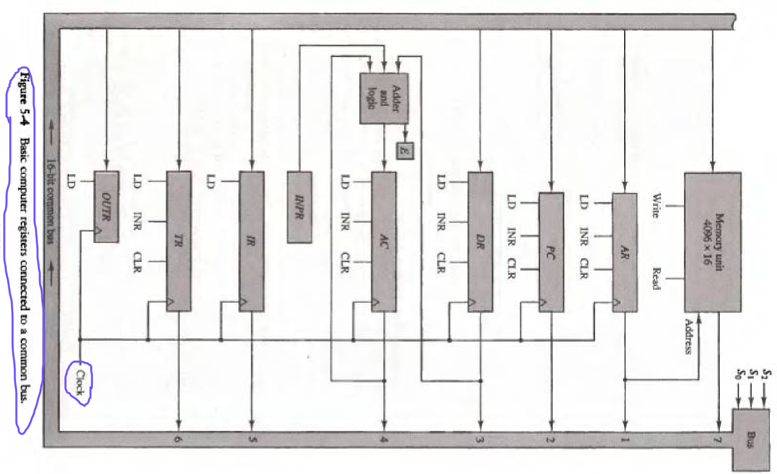

Instruction Format
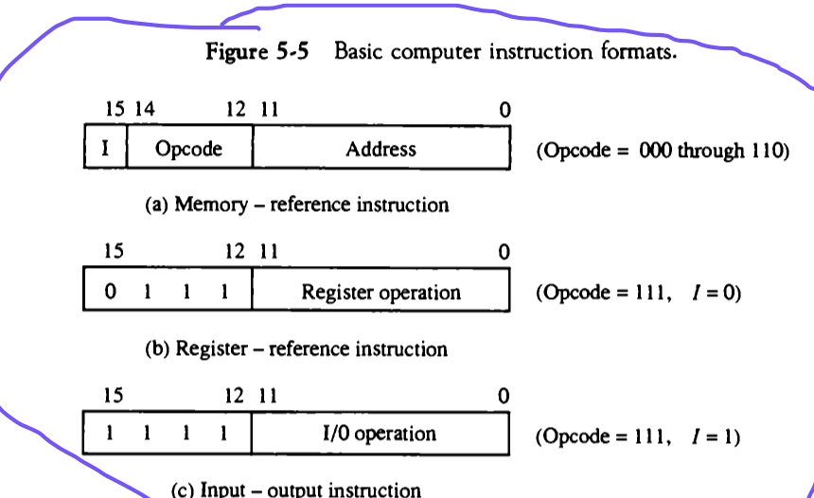
“I” refers to the type of address, 0 for direct and 1 for Indirect address

Instruction Set Completeness
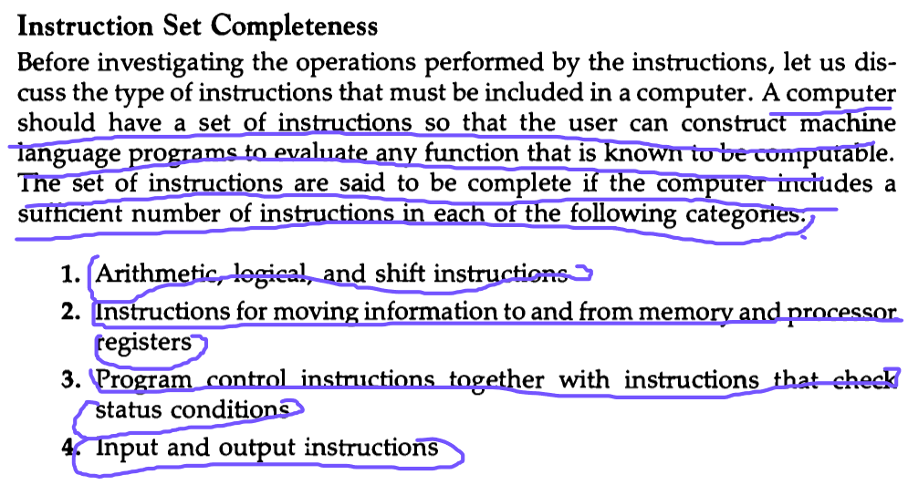

Hardwired and Microprogrammed Control
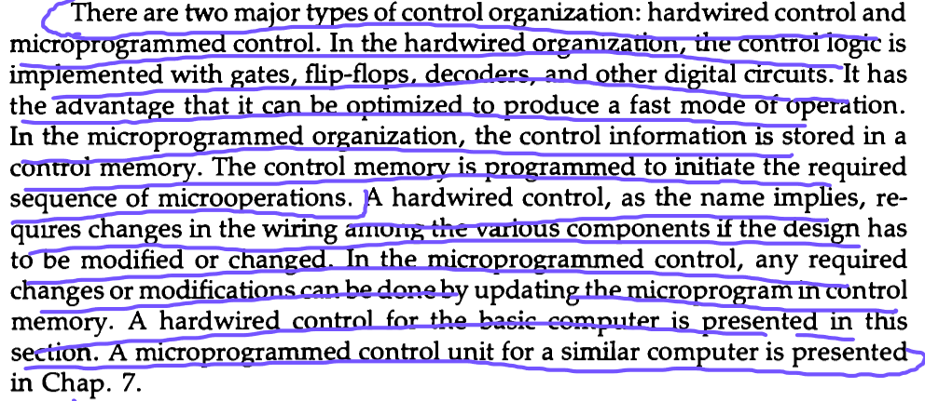
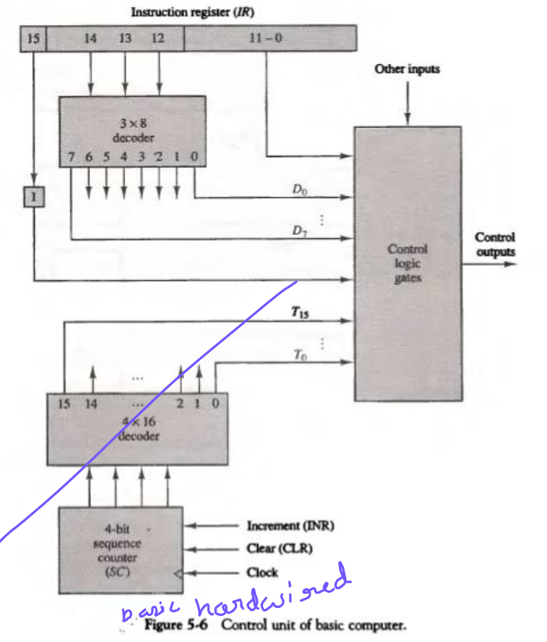

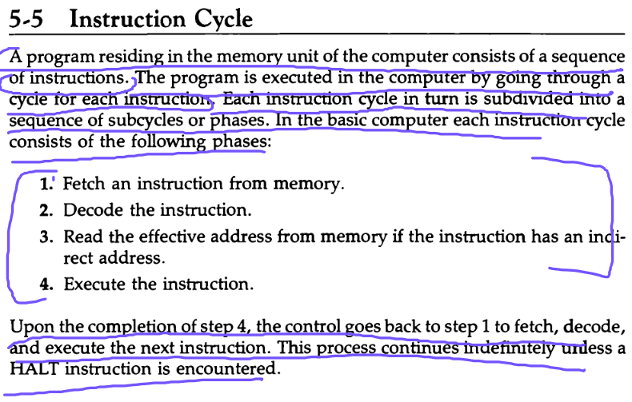
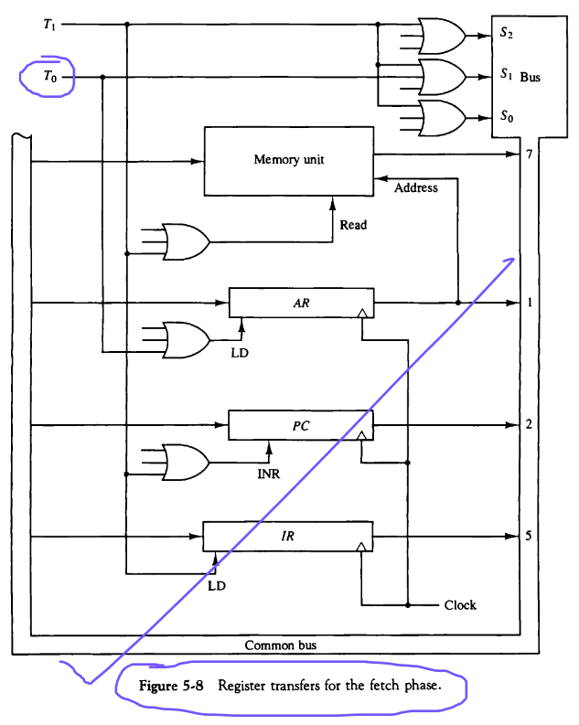
Fetch And Decode

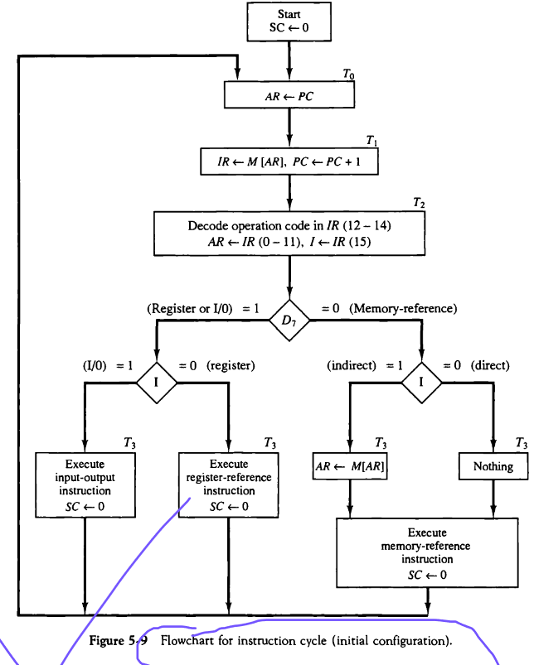
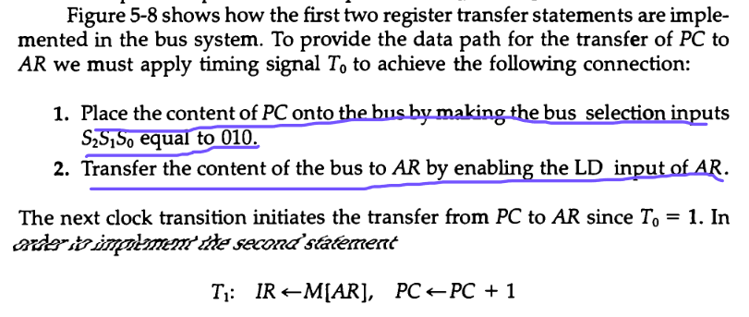
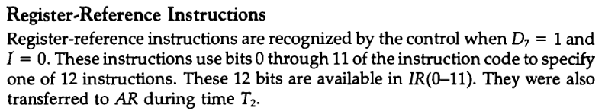
Memory Refernce Instruction
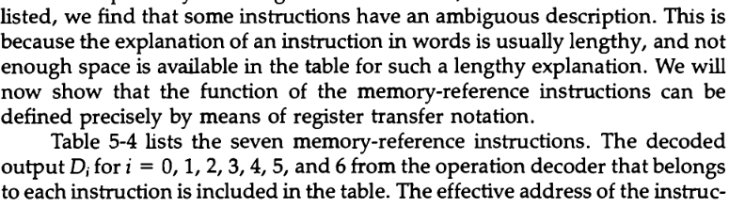
Register Transfer Language (RTL)
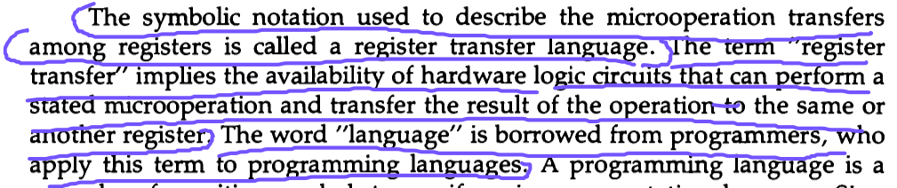
Register Transfer
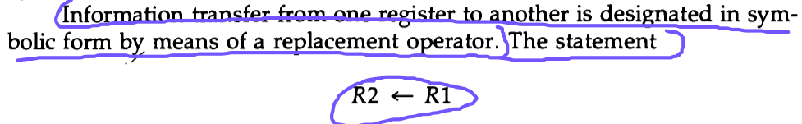
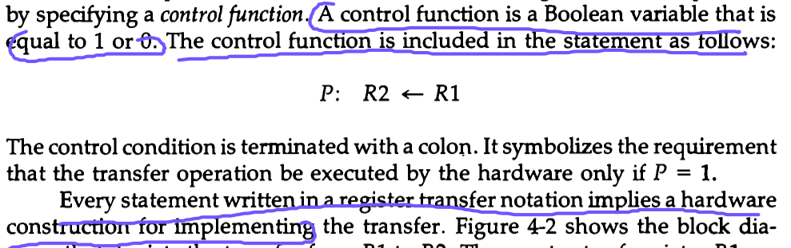
Control Function
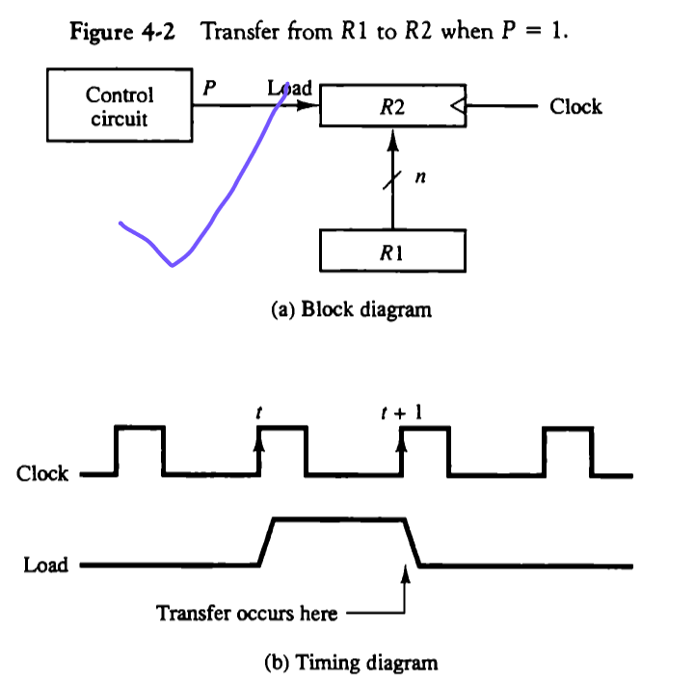

Common Bus
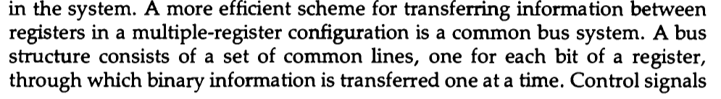
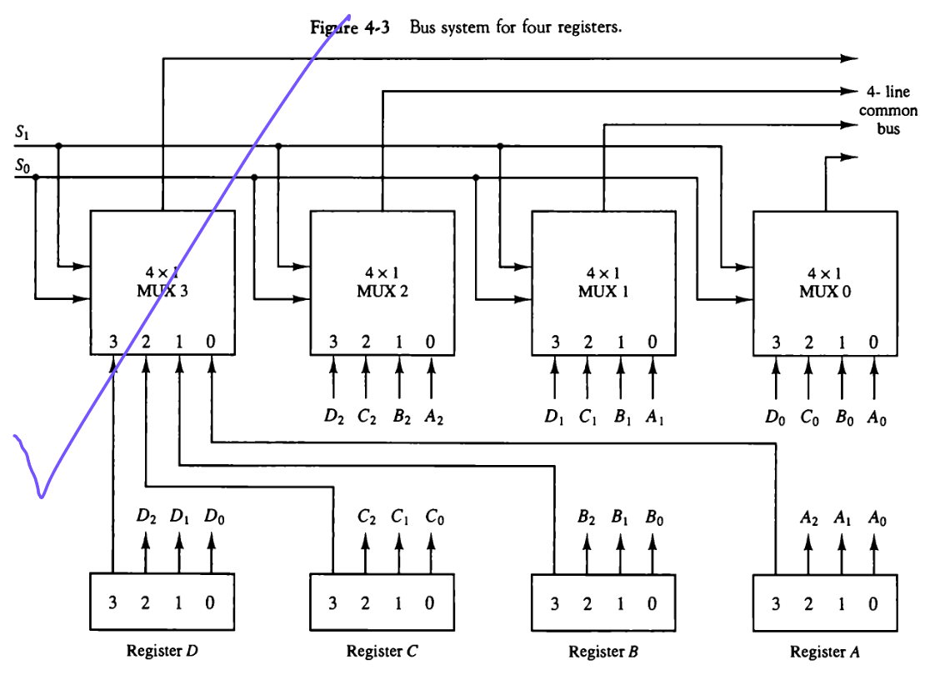
Arithmetic Microoperations
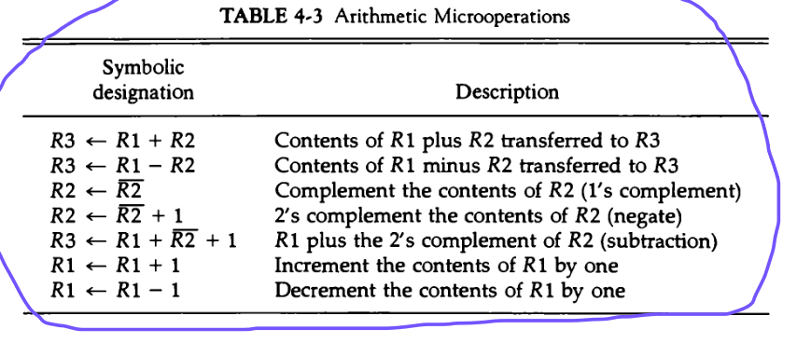
Arithmetic Circuit

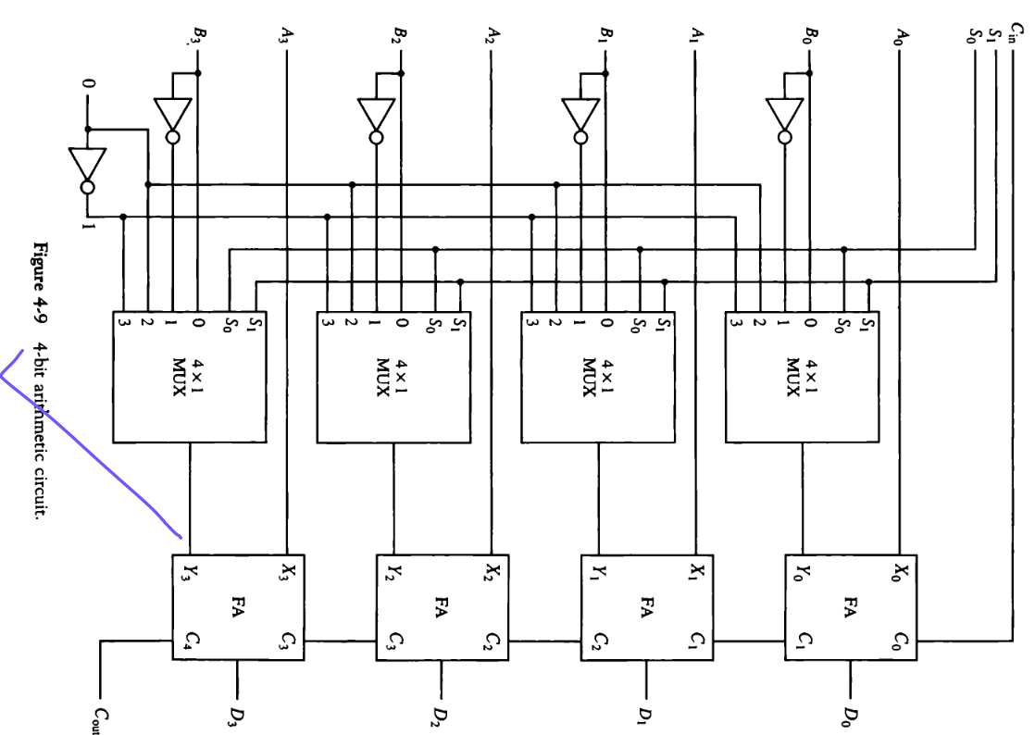

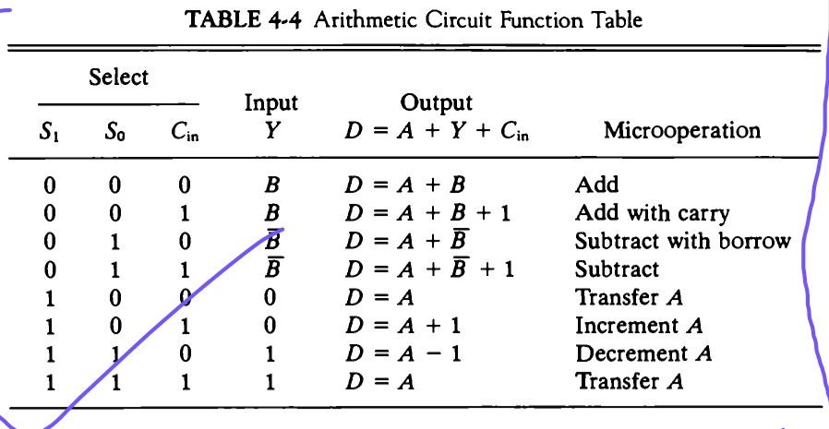
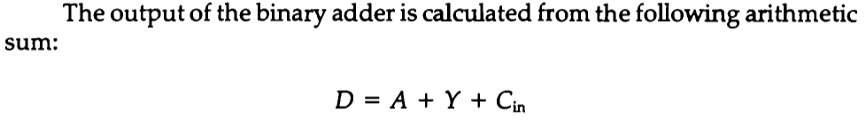

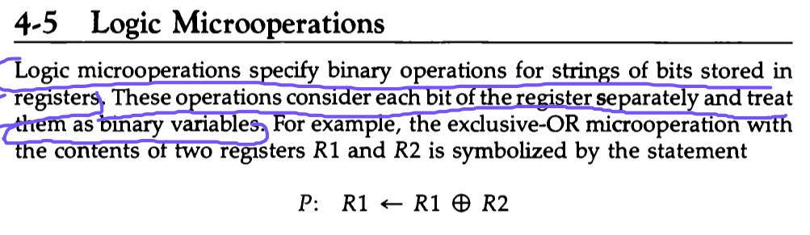
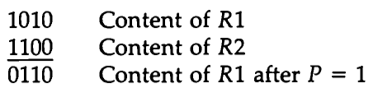
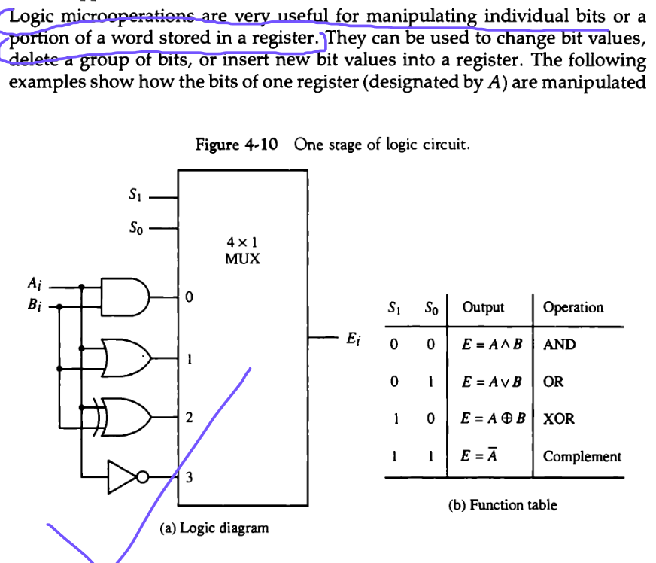
Logic Circuit
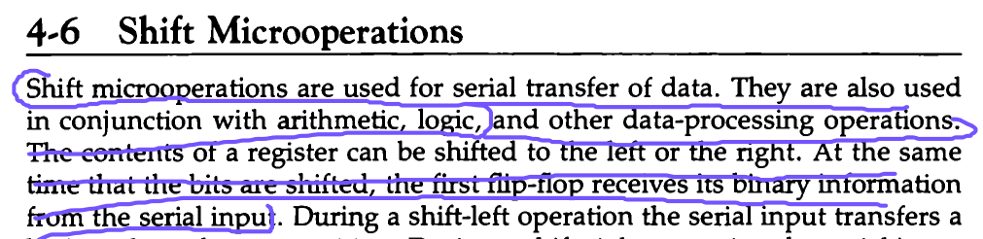
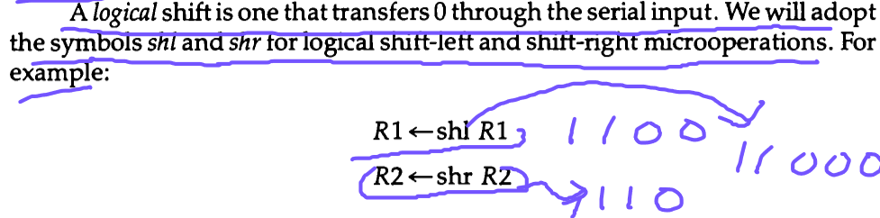
Logical Shift
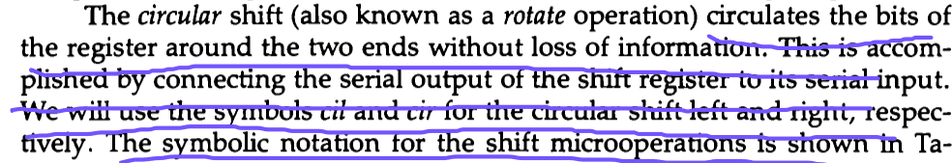
Circular Shift

Arithmetic Shift
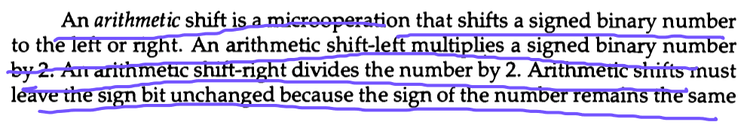

Shifter

A shifter, in the context of digital design and computer architecture, is a hardware component or circuit responsible for performing bitwise shift operations on binary data. A bitwise shift involves moving the bits of a binary number to the left or right by a certain number of positions. Shifters are commonly used in processors, microcontrollers, and other digital systems for various purposes
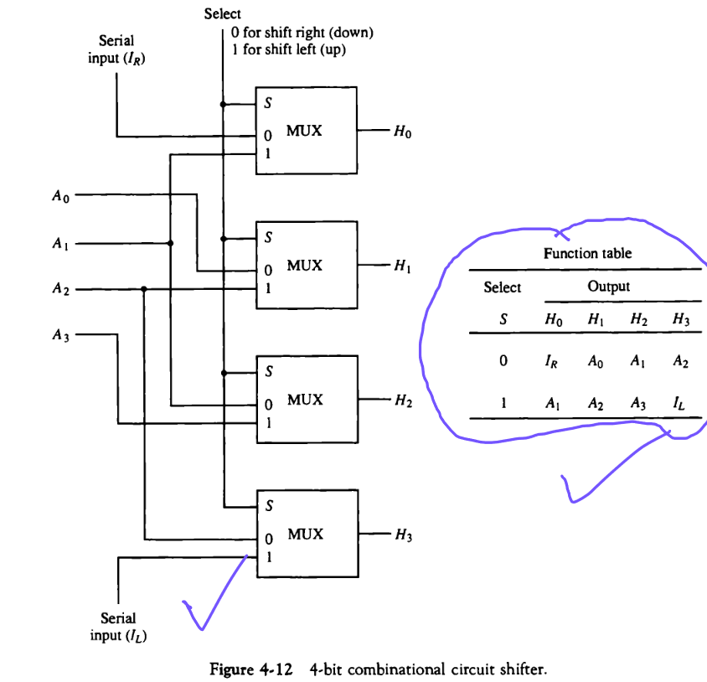
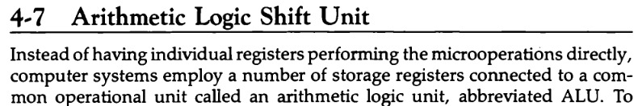

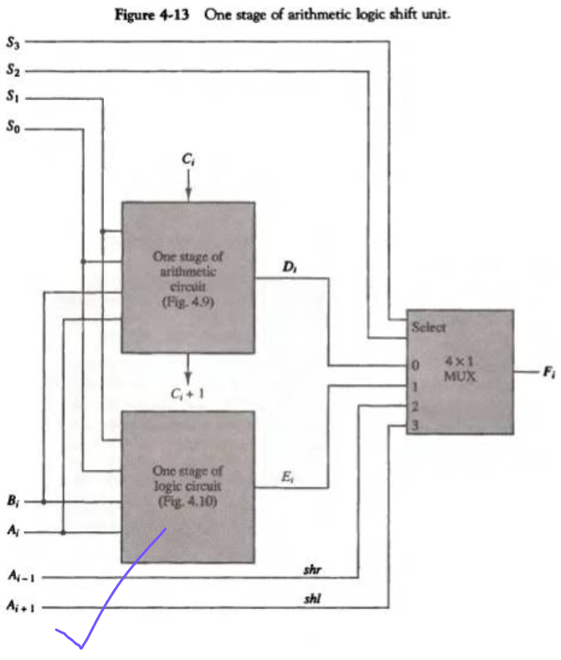
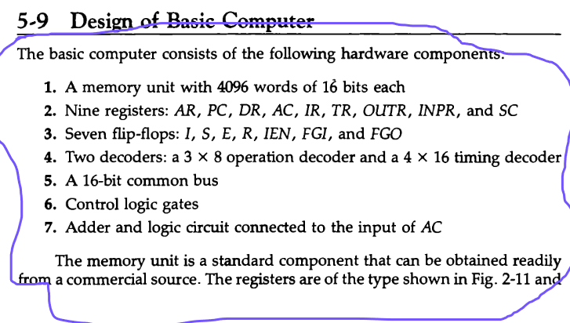
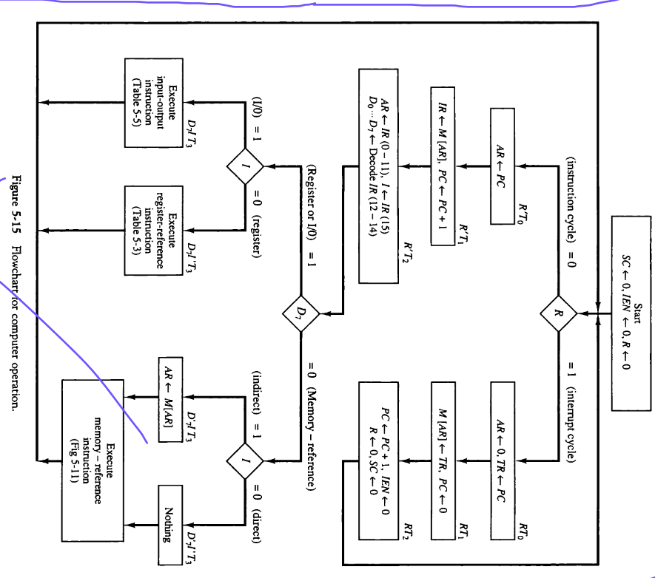

Instruction Set
An instruction set is a collection of instructions that a particular central processing unit (CPU) or microprocessor understands and can execute. Each instruction in the set represents a specific operation that the CPU can perform, such as arithmetic operations, data movement, logical operations, and control flow instructions.

Symbolic Code
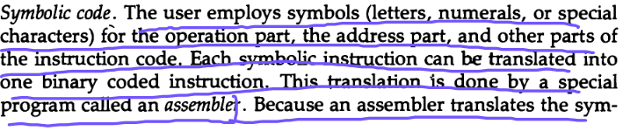
Machine Language
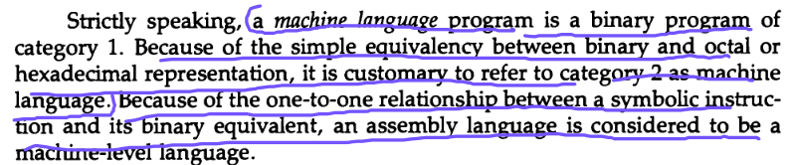
Assembly Language

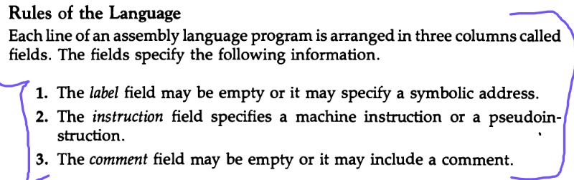
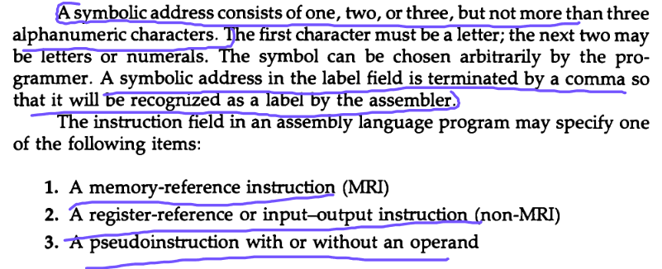
Pseudo-instruction

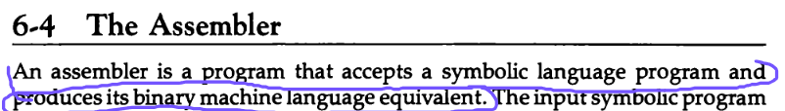
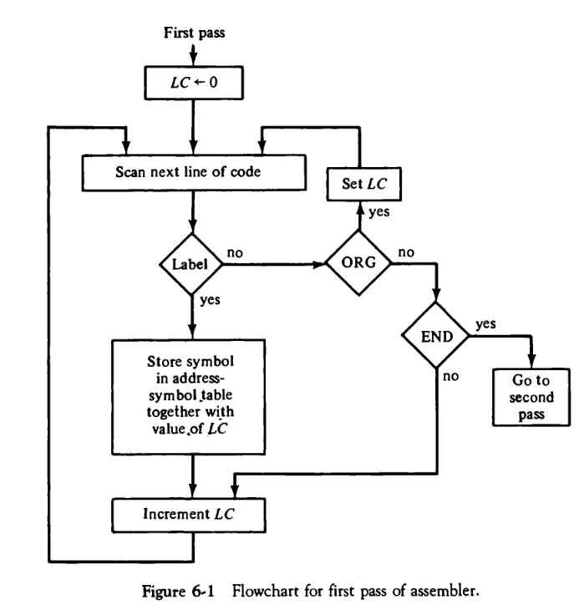

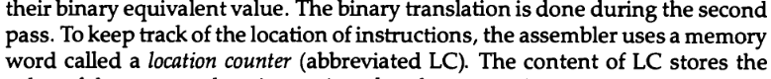
Control Unit
Microprogrammed Instruction
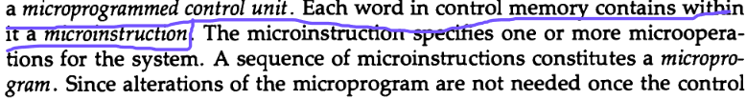
Control Memory
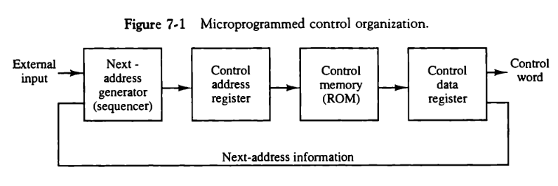
Control unit diagram
Control Address Register
Sequencer
Pipeline Register
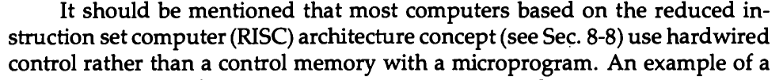
Routine
Mapping
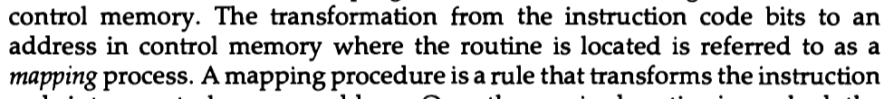
Capabilities of Address Sequencing
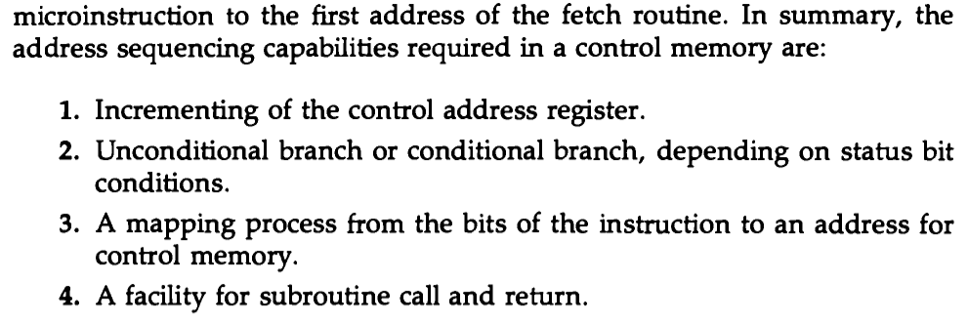
CAR (Control Address Register)

Control memory address register specifies the address of the micro-instruction, and the control data register holds the micro-instruction read from memory, The micro-instruction contains a control word that specifies one or more micro operations for the data processor.

Special Bits
Branch Logic
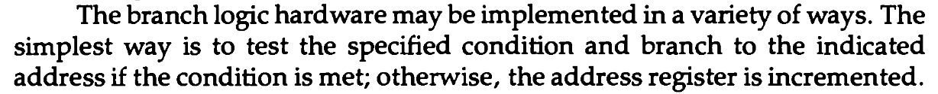
Microprogrammed Control Unit Diagram
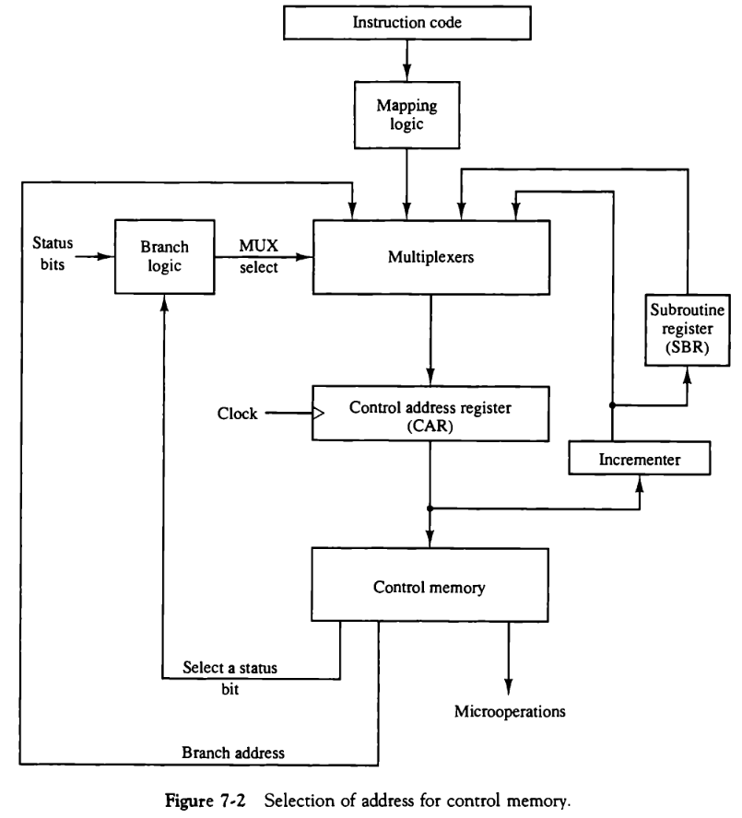
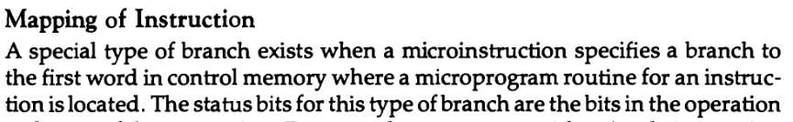

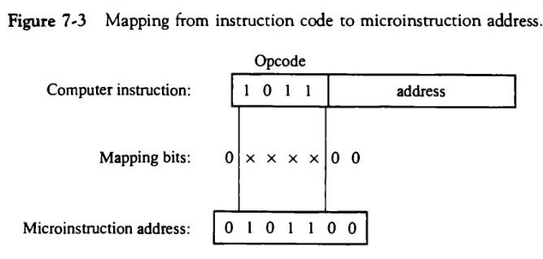

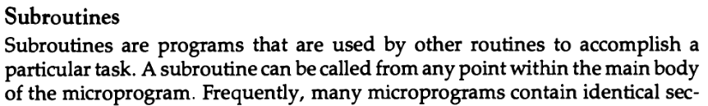

Subroutine Register

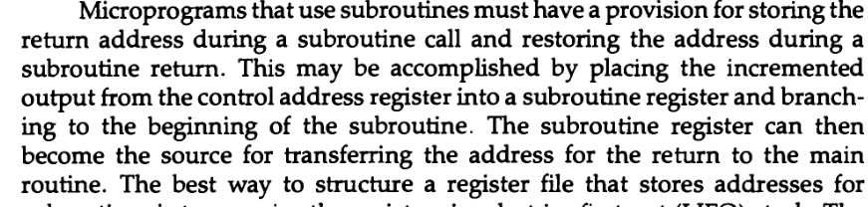

Hardware Configuration of Computer
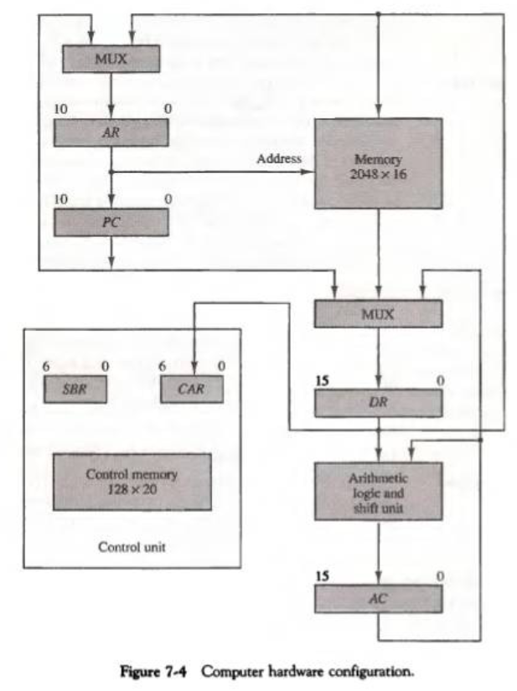

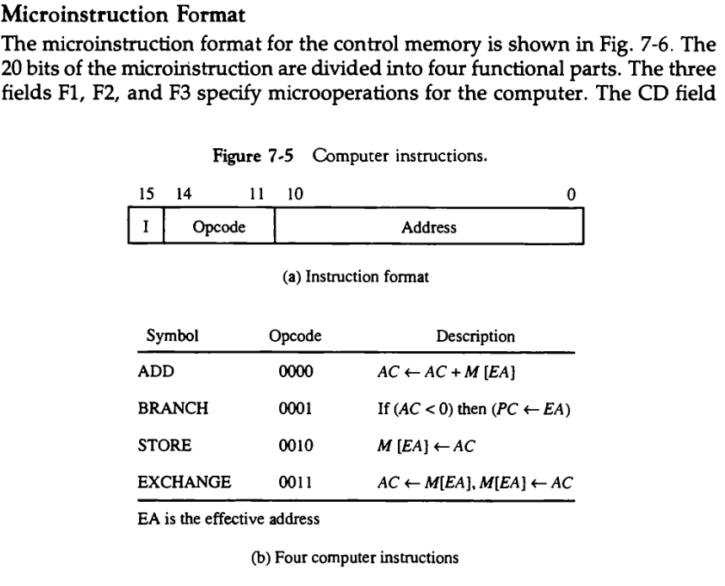
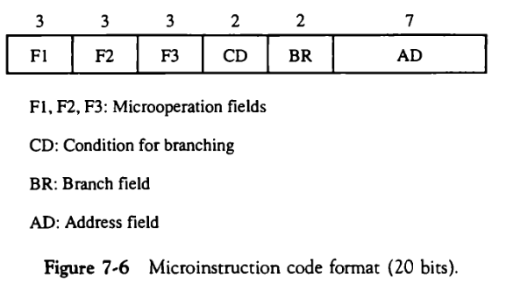

Conditional Field
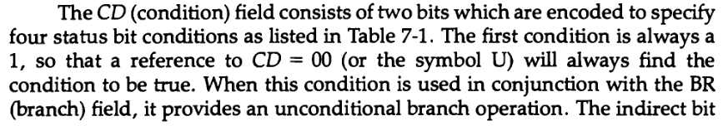
Branch Field
Symbolic Microinstructions
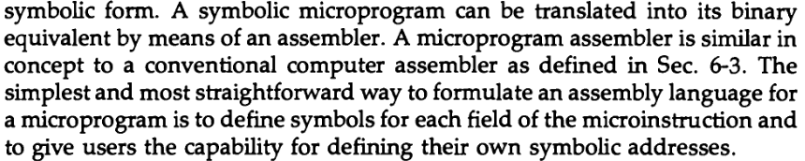
Fetch Routine
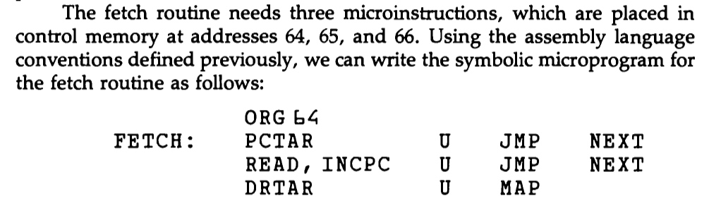
ORG64
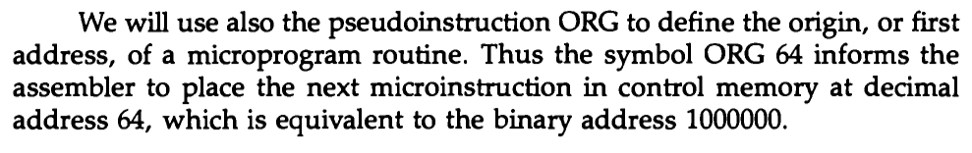
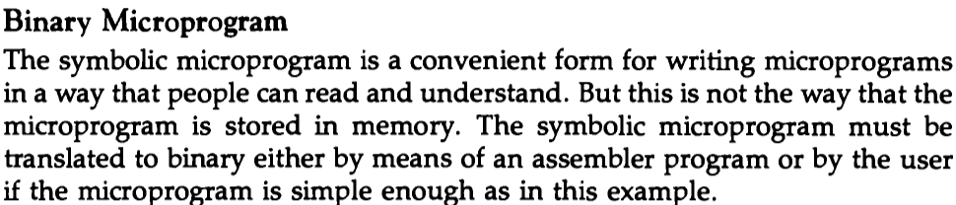

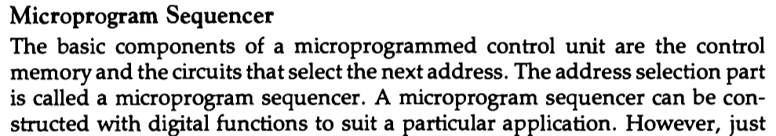
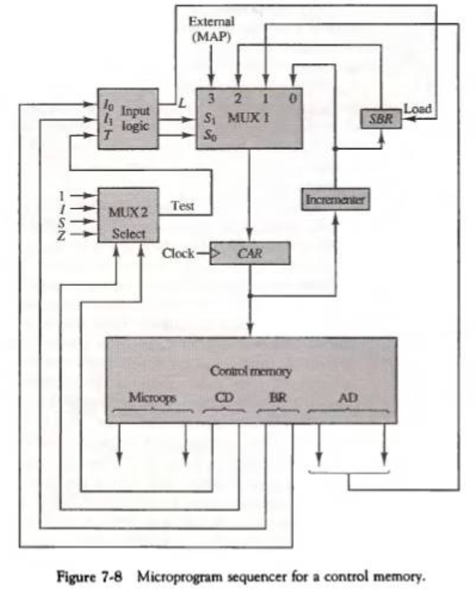
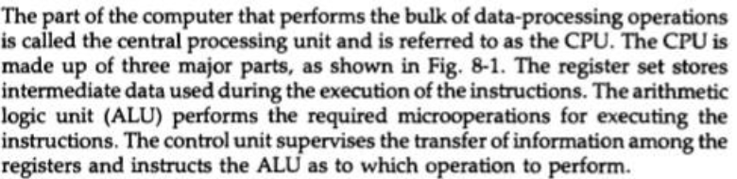
CPU
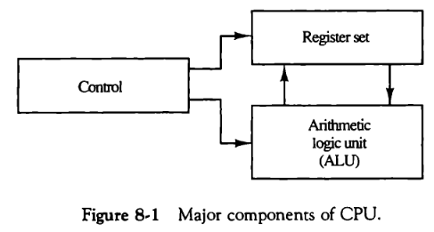

Instruction Format
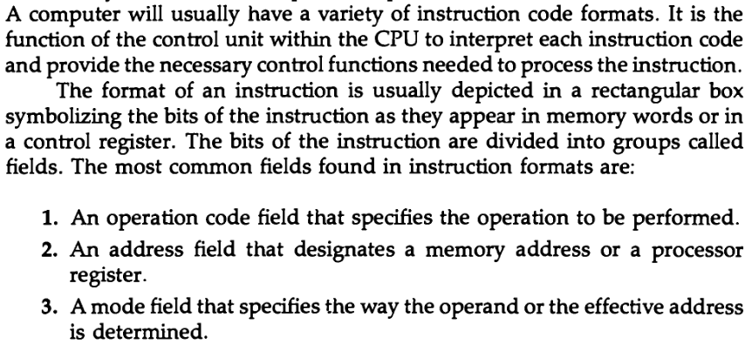
Register Address
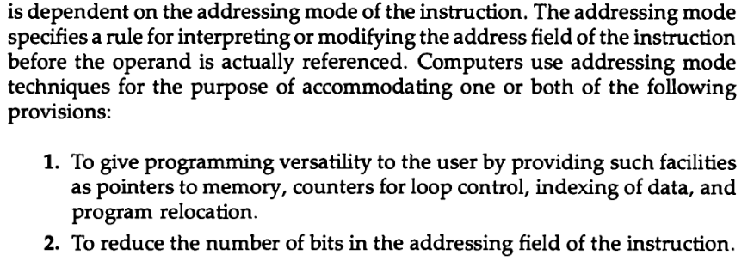
Addressing Mode
Control unit during Instruction Cycle
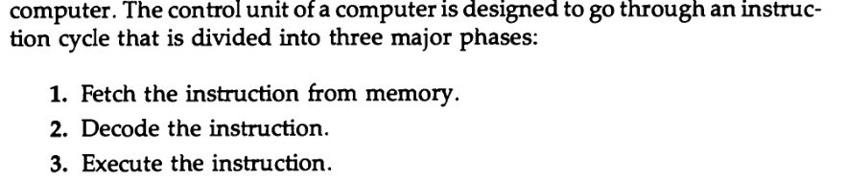
Mode Field
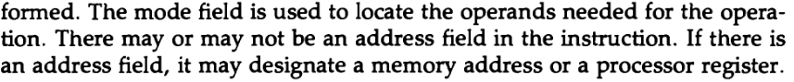
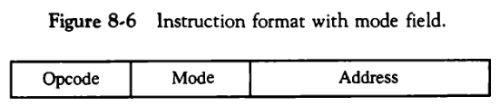

CISC Characteristics

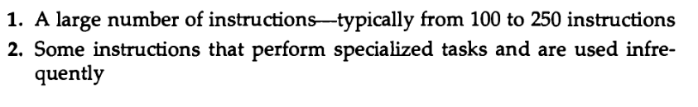
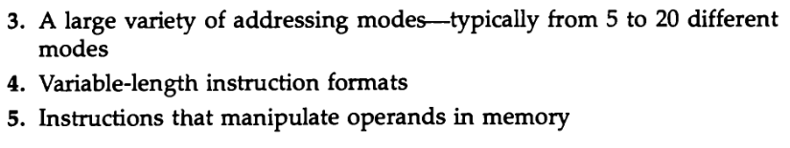
RISC Characteristics
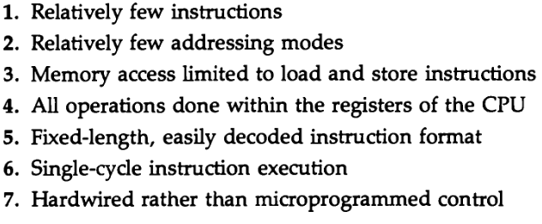

Machine language instructions

They are the low-level instructions that a computer's central processing unit (CPU) can directly execute. These instructions are represented in binary code, consisting of sequences of 0s and 1s, and they correspond to specific operations that the CPU can perform.

Data Path

This refers to the portion of a processor that is responsible for performing arithmetic and logic operations on data. It is a critical component that facilitates the movement and manipulation of data within a processor. The data path is where actual computation takes place, and it typically includes registers, arithmetic logic units (ALUs), multiplexers, and other components.

Horizontal microprogramming is like using a single recipe card for each step of a cooking process. Each card (microinstruction) contains all the details for a specific action, from chopping vegetables to stirring the soup. Each microinstruction is a standalone set of instructions, like separate recipe cards for each cooking step.

Vertical microprogramming is like having a single recipe card with checkboxes for different tasks. Instead of having separate cards for chopping and stirring, you have one card with checkboxes that you mark as you complete each step. One microinstruction covers multiple tasks, and each task has its dedicated bit or field, akin to a single recipe card with checkboxes.

